RESUME

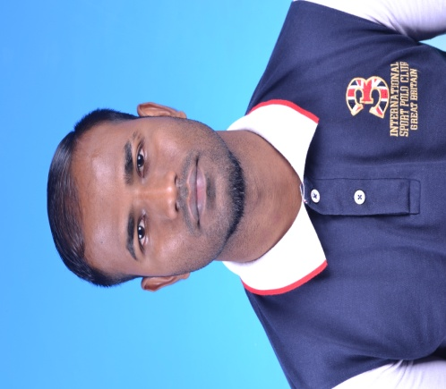

Karthikeyan A/L Nadarajan(ADAM)

26-9-12,Jalan 1/2D,taman seri murni,68100 Kuala Lumpur,W.P

|  |
| --- |
| **CARRER OBJECTIVES** |

To use my skills in the best possible way for achieving the company's goals and enables me as a fresh graduate to grow.

|  |
| --- |
| **EDUCATIONAL BACKGROUND** |

|  |  |  |
| --- | --- | --- |
| Universiti Kuala Lumpur British Malaysian Institute Gombak Selangor,  Bachelor of Engineering Technology(Hons) in Electrical  **Grade :second class lower** | Politecnic Merlimau Melaka,  Diploma in Electrical Engineering  **CGPA** : 3.45  _______________________________________________________________ | **SKILLS**  CNC Machine (Lathe and Milling)  Proteus (Intermediate)  Multisim (Intermediate)  Pspice (Intermediate)  Pro-E (Beginner)  Solid Work (Beginner)  *Language (Spoken & written)*  Bahasa Malaysia (Proficient)  English (Fluent)  Tamil (Proficient)  Mandarin (Very Basic) |
| (January 2007 – December 2007)  SMK(A) Seri Garing, Rawang  Major : Science Invention  SPM : 1A 7B’s 1C & 1D |

|  |
| --- |
| **INTERNSHIP EXPOSURE** |

***Zka Engineering (08 Disember 2013 – 22 April 2014)***

1. Technical support in solving engineering problem.
2. Troubleshooting technical problem and supervising junior technicians.

|  |
| --- |
| **WORKING EXPERIENCE** |

**Tricomas Sdn.Bhd (September 2011 – January 2012)**

**Position:** Technician

**Responsibilities:** Solving and troubleshooting printing machines.

**Dr.CARDIN SDN BHD ( January 2011 – July2011)**

**Position:** Grocery worker

**Responsibilities:** 1.Promoter

|  |
| --- |
| **CURRICULAR ACTIVITIES** |

* Represented school in Police Cadets Marching National
* Represented school in athletic
* Represented school in football
* Committee for Karnival Sukan-Sukan University (2010)
* Committee member of Even day Unikl BMI (2012)
* Committee member of CIDB Program (2013)

|  |
| --- |
| **OTHER** |

* Able to write and converse fluently in Malay and English
* Able to work under pressure
* Fully commitment on working
* Willing to learn a new thing and fast leaner

|  |
| --- |
| **PERSONAL PARTICULAR** |

Name :KARTHIKEYAN A/L NADARAJAN(ADAM)

Permanent Address :26-9-12,Jalan 1/2D,taman seri murni,68100 Kuala Lumpur,W.P

Contact No :+6 017-3055458

Email : Adam_rock89@yahoo.com

I/C No : 890510105097

Hobby : Football, futsal and music

Marital Status : Single

Race / Religion : India / hindu

Health : Excellent

|  |
| --- |
| **REFEREE** |

Mdm. Zurin Zuraida Mr. Samsul Zahari Shahidin

Lecturer, Faculty of Electronic Lecturer, Faculty of Electrical

Engineering, Engineering, UniKL Brtish

UniKL British Malaysian Institute, Malaysian Institute 53100 Gombak

53100 Gombak Selangor, Malaysia Selangor, Malaysia.

Mobile No : +603-61841000ext146 Mobile No : +603-61841000ext256